City schools invest in meditation
Thursday, July 20th, 2017
By Chris Papst

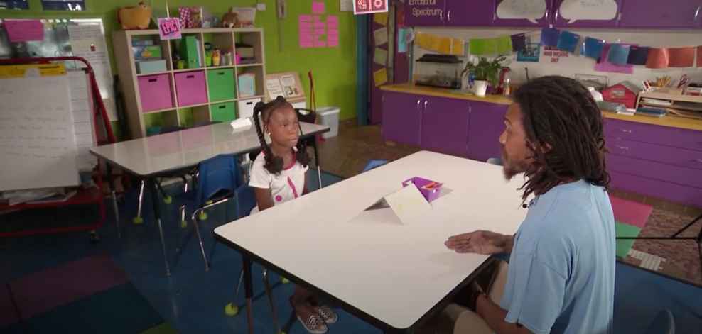
BALTIMORE, Md. (WBFF) -- Mindful Moment Rooms are becoming more popular in Baltimore City Schools, even as budgets are shrinking.
"A lot of our kids deal with a lot of trauma in their lives,” says Liberty Elementary Principal Joseph Manko. “To have the school be a place where they can be mindful and meditate, calm themselves and relax, I think will be really helpful."
This past year was difficult for Principal Manko. Deficits forced him to cut two full-time teacher positions at about $100,000 apiece. Still, he found $45,000 in his budget to hire two instructors to staff a new Mindful Moment Room, where kids practice meditation and breathing techniques to reduce stress and increase focus.
It's an investment Manko believes will pay off in the classroom.
"If it wasn't going to make a difference, we wouldn't be doing it. We are very judicious with our funds. We make sure every dollar that is spent is done to benefit kids," he says.
Liberty Elementary will become the 18th school in Baltimore City to adopt the program, which is run by Baltimore-based Holistic Life Foundation. Atman Smith co-founded the company.
"Instead of punitive, it's more of a restorative practice," Smith says.
At Liberty, every student will meditate twice a day. Students who misbehave will not go to the principal's office, they'll be sent to the Mindful Moment Room to calm themselves.
"We're not naive. We know what these kids are dealing with,” Smith says. “Baltimore is like the jungle, man. It's a lot of murders. A lot of crimes. A lot of things that bring about trauma."
But does it make a difference? For eight years, Robert Coleman Elementary has had a Mindful Moment Room, and according to District data, zero students have been suspended for the last two years. But at City Springs, suspensions have doubled since mindfulness classes were added three years ago. But Principal Manko believes this will help students.
"I think we as adults, we have not given our children, the skills they need to deal with some of the challenges around them," Manko says. "Based on the research we have seen, and based on what we think our kids need and what will support them, we think this will hopefully prove to be a wise investment for their futures."

